The sections shaded green are queries for you. In some cases, I need you to flesh out the text a bit more. In others I find the text confusing and need you to explain the concept a bit more clearly.

Any text shaded yellow is what I have included, please confirm that this is correct.

Any text shaded blue is available on doing a quick google search. Please amend this text.

Section 1.1.4 *Describe different types of CPU’s with regard to use, and power*

### Different types of CPUs in terms of use and power

**[I'm not sure that we reference power]This is in reference to either 32 bit and 64 bit. I am OK with removing the word power**

In Section 1.1.3 we outlined the types of processors based on the number of cores. Processors can also be categorised based on:

* Data bus width e.g. 32-bit and 64-bit processors;
* Brand name and manufacturer e.g. Intel and AMD;
* Architecture e.g. Reduced Instruction Set Computing (RISC) and Complex Instruction Set Computing (CISC); and
* General purpose processors based on architecture – in this category we have five types which are explained below.

**Key differences between RISC and CISC processors**

**[need some more info about what is RISC and CISC? Just short introductory type sentence]**

When discussing computer instruction sets, one of the key distinctions we draw is whether a certain machine is a CISC (Complex Instruction Set Computing) or a RISC (Reduced Instruction Set Computing) (Reduced Instruction Set Computing). The nature of their instruction sets is one of the main characteristics between computers based on each of these computer architectures, as the names imply. CISC architecture dominated in the early 1960s and late 1970s, whereas RISC architecture took over in the late 1980s. CISC contained several machine instructions, and individual instructions were frequently rather complex. The RISC approach, on the other hand, was not only to have fewer different machine language instructions, but also to have each instruction do less work. Table 1.2 shows the key differences between the two main types of computer processors.

|  |  |
| --- | --- |
| **RISC** | **CISC** |
| The instruction set is reduced, most instructions are very primitive. | The instruction set is very large, and can be used for complex operations. |
| The computer’s execution time is very low. | The computer’s execution time is very high. |
| Code expansion may create a problem. | Code expansion is not a problem. |
| The decoding of instructions is simple. | The decoding of instructions is complex. |
| It doesn’t require external memory for calculations. | It requires external memory for calculations. |
| There are multiple register sets present. | It has only a single register set. |

***Table 1.2: Differences between the two main types of computer processors***

**General purpose processors**

**[I have included the text shaded yellow below, to provide some context/introduction. Please confirm it is correct.]**

In modern technology, the processor is often not a computer in the sense that we normally think of a personal computer or business computer. It may take the form of a processor within a smartphone, car or vacuum cleaner. These processors may be a chip or integrated circuit. There are five types of general-purpose processors, and these are: microcontroller, microprocessor, embedded processor, digital signal processor (DSP) and media processor.

**Microcontroller**

**[I have changed the original (shaded blue) and included text shaded yellow below, to bring this more in line with the description of microcontrollers in Robotics. Please confirm it is correct]**

~~A microcontroller is basically a type of computer that comes in different packages and sizes.~~ A microcontroller is a type of computer that is a compact integrated circuit (packaged in different shapes and sizes) that is designed to control one specific operation. This operation will generally take the form of feedback on reading input and output through General Purpose Input Output (GPIO) ports.

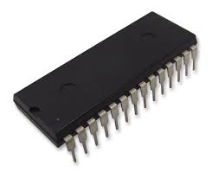

**Figure 1.4: Example of a microcontroller (PIC32MX Series Microcontrollers)**

[AW: source? Or redraw?]

**[text shaded BLUE is available on a google search, please modify]**

**Microprocessor**

A microprocessor is a very compact electronic circuit capable of performing ALU operations and connects to the main circuit board via connection pins moulded into it. The microprocessor's size, shape, and number of pins are determined by the quantity of data it is designed to manage. A microprocessor is easily affected by moisture or contact; thus it is enclosed in plastic or ceramic to provide some protection.

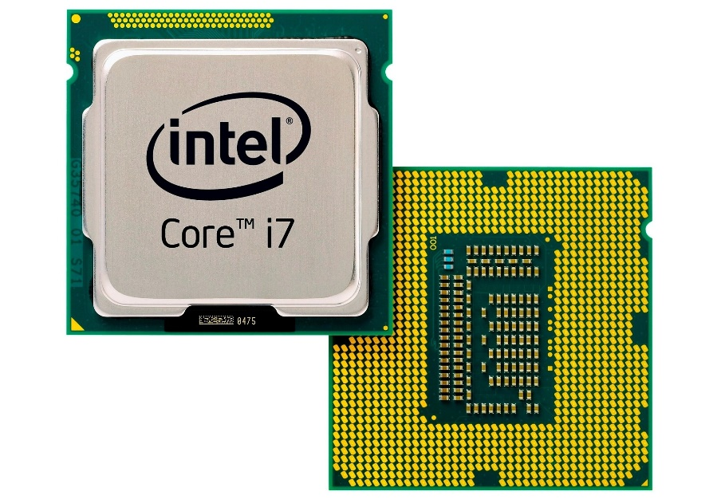

**Figure 1.5: Example of microprocessor**

[AW: source? Or redraw?]

Microprocessors are becoming cheaper, offering high speed, becoming smaller in size and consuming less power than the older models and generating less heat. However, when compared to microcontrollers, microprocessors generally consume more power and this is why they require cooling fan.**[compared to what?]**

Microprocessors uses a clock signal to control the rate at which instructions are executed, synchronize other internal components, and to control the data transfer between them.

**Embedded processor**

An embedded processor is a kind of computer chip that is utilized inside devices to give additional functionality in areas such as control, mechanical, and electrical monitoring. An embedded processor can be programmed particularly for the task at hand. As a result, it can support a wide range of CPU architectures. Embedded processors are designed especially for coping with the needs of an embedded gadget.

Embedded processors may be observed in transportable devices like smart [**not sure what you mean by virtual can i change to sports/activity/smart?]** watches, PDAs, digital cameras, GPS gadgets and MP3 players. They can also be located in large structures such as visitor’s lights, systems controlling energy, vegetation and factory controllers.

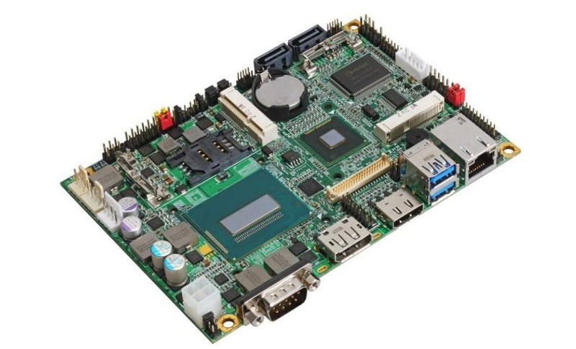

**Figure 1.6: Embedded processors [https://microcontrollerslab.com/embedded-processors-types/]**

[AW: source? Or redraw?]

**Digital signal processor**

A digital signal processor is a customized microprocessor chip with an architecture intended for digital signal processing operations. Digital Signal Processors (DSP) take real-world signals like voice, audio, video, temperature, pressure, or position that have been digitised and then mathematically manipulate them. A DSP is designed for performing mathematical functions like add, subtract, multiply and divide very quickly.

To obtain a clear signal, signal processing can be done using a computer or Application Specific Integrated Circuits (ASIC), Field Programmable Gate Array (FPGA), or Digital Signal Processor (DSP). DSP processors are found in oscilloscopes, barcode scanners, mobile phones, printers, and other devices.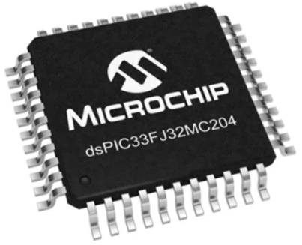

**Figure 1.7: Example of 16-bit digital signal processor 40 million instructions per second (MIPS)**

[AW: source? Or redraw?]

**Media processor**

Media processors are all-in-one stations for generating, recording, and streaming audio-visual presentations. Media processors record independent video inputs and live program outputs.

[**please supply text**]

### Computer memory

The **computer memory** is the storage space in the computer. It is divided into a large number of small cells. Each location or cell has a unique address, which varies from zero to memory size minus one. For example, if the computer has 64K words, then this memory unit has 64 × 1 024 = 65 536 memory locations. The addresses of these locations vary from 0 to 65 535. The CPU is responsible for selecting memory cells to read or write data.

**VOCABULARY**

Computer memory is the electronic storage location for the instructions and data that a computer needs to access rapidly.

The concepts of *memory* and *storage* can be easily confused as the same thing; however, there are some distinct and important differences. Briefly, memory is primary memory, while storage is secondary memory. A computer's storage enables its user to access the data and applications stored on the device securely. We make use of storage devices such as magnetic storage devices, optical storage devices, flash memory devices and online cloud storage.We will explain these terms in detail in Section 1.1.7. [**storage not really referenced again?**]

### 1.1.6 The primary purpose of memory

Memory is central to a computer's operation because it forms the critical link between software and the CPU. A basic function of computer memory is to store data. However, memory performs several different functions depending on the type of data it stores and the role it plays in computer operations. Although all of these components involve data storage, RAM, ROM, flash memory and hard drives each perform a different and necessary function to keep a computer and its peripherals working. Computer memory likewise decides the size and number of programs that can be run concurrently and helps to optimise the capabilities of processors.

Once data is stored in computer memory, the data will remain there forever (or until such time as you decide to delete it). Each time memory is full, then the data can be deleted in part or completely, to be replaced with new data. The performance of a computer depends on both memory and the CPU. The CPU cannot store programs or a large set of data permanently. It is only capable of storing basic instructions required to operate the computer. Therefore, it is mandatory to have the memory to run a computer system properly.

### 1.1.7 Different types of memory and their purposes

There are basically two broad categories of memory: internal memory and external memory.



**Figure 1.8: Categories of computer memory**

[AW: REDRAW]

To further assist us in understanding computer memory, we will use a computer hierarchy chart and then explain each type.

**Figure 1.9: Memory hierarchy**

[AW: REDRAW using different colours]

[**very confusing, please rephrase this paragraph]**

A Memory Hierarchy is a feature that helps organize memory to reduce access time. Memory can be divided into five major hierarchies based on speed and use and these are:

* Registers
* Cache [level 1 and level 2]
* Main(primary) memory
* Disk (secondary) memory
* Backup storage e.g. cloud storage

It is easy for processors to move from one level to another according to their requirements. Access time, capacity increases as one moves from the top in the hierarchy moving downwards while cost per bit increases from bottom to top. The cost of external memory is lower than that of internal memory. In addition, registers are faster than hard disks. The memory hierarchy affects the performance of computer algorithms, predictions, architectural designs, and lower-level programming constructs involving locality of reference.

Locality of reference refers to a computer program's tendency to access instructions whose addresses are close to each other.

Figure 1.9 illustrates an example of memory hierarchy in computers.